Deep Vein Thrombosis and Chronic Venous Insufficiency
Summary
Chronic venous insufficiency (CVI) in most of the cases goes hand in and with the varicose vein which cause pain and the swelling on the lower limb pain, below the popliteal fossa. The causative agent is a malfunctioning valve which when there is stasis of blood due to severely impaired blood circulation in the veins on the lower limb. The other etiology of the is when the valves are damaged or blocked due to bacterial infection or other disease process.
It is a disease process that may end up causing deep vein thrombosis due to the stasis of blood and poor circulation that end up activating the clotting factor to form a clot known as thrombus. The sequelae of a chronic venous insufficiency are varicose vein, itching effect and ulceration of the ankles. Epidemiologically, vein disorder is among the diseases that are classified in chronic conditions than the artery related diseases.
On the other hand, deep vein thrombosis is a complication of chronic venous insufficiency. Failure to manage the CVI early and prevent its poor prognosis, varicose vein end being formed that aid in the stasis of blood and at the end a thrombus is formed mostly in the saphenous vein forming what is known a deep vein thrombosis. The clot or a thrombus that is formed on a deep vein can occur on other part such as the arm, abdomen. The most common symptoms are discoloration which also happen in the CVI, swelling and extreme pain. The symptom of both the CVI and the deep vein thrombosis are similar.
Epidemiology
Globally, CVI and DVT are economically advanced countries. It has been associated with sedentary lifestyle. More so, 2 to 3 of the adult demographic are affected by the DVT and CVI with 80 percent having ulceration. It is more in women population with its summit being at 40-49 years old (Michiels, and Maasland, 2016). The prevalence of the two diseases is rated at one percent in lower age cohort but the it increases to 3 percent as the population ages.
Chronic venous insufficiency is a concern in the public health and among the leading on the disease burdens in the United State of America. At least 6 percent of the Americans are affected by the CVI. The cases mentioned alone are at 60 percent of the adult demographic. More than 490,000 people in America are affected by stasis of blood on the veins. For every 150, 000 admission cases in America, 97 of the cases are due to CVI or DVT related.
Pathophysiology of Chronic Vein Insufficiency and Deep Vein Thrombosis
Deep vein thrombosis starts with failure of the venous valves to operate optimally. Some of the causes of impaired valves include congenital malformation where the wall of veins is week that dilate abnormally with the pressure which end causing a malformation of the valves. Traumatic events may also damage the valves (Büyükyılmaz and Şendir,2015). Some of the veins are damaged when there is a surge of hormones in the body especially in women during pregnancies.
Once the venous valves are damaged, the stasis of blood ensues. This is because the valves are important in preventing the backflow of blood hence preventing the pooling of the blood in the veins. The pooling or the stasis of the blood in the veins end activating the blood clotting factors. Inflammation also may release chemicals that end up triggering the clotting of blood.
The normal blood pressure alteration is also affected with flabby vein during ambulation. In normal vein, it was determined by research done by Elder & Greer (2015) that the pressure of vein is reduced by the calf muscle by 60 percent during ambulation in the lower limb. This physiology is impaired in the flabby veins where the pressure is only reduced by 18 percent. To that effect, the chronic venous insufficiency results which follow the following sequence.
The venous pressure becomes more than the venule pressure on the capillaries which impair the flow of blood to the arterial part. Then the flow rate is reduced which end up trapping the leukocytes in the blood. The leucocyte that are trapped start releasing enzymes and radicals of free oxygen. The clotting factors such as plasma protein get the access in the surrounding tissues. The area become edematous due to the inflammation hence symptoms of pain, swelling and reddening. This end forming the clots in the vein that saphenous vein that is known as deep vein thrombosis.
Etiological Factor
There are many patient factors that can cause both the CVI and the DVT. One of the factor is gender of the patient. In most of the cases, the female gender has had higher cases of both DVT and CVI. The higher prevalence of these disease process in women is because of more hormones in their system. The prognosis becomes more apparent especially during pregnancies or using hormonal family planning (Fukushima & Takaso, 2016). The hormones have an effect of softening the venous vein making them flabby and ineffective in preventing the backflow of blood. Consequently, the blood stasis results. More so, flabby valves cause venous hypertension making blood in vein to supersede the pressure at the venules near the capillaries hence impairing the flow of blood. The leukocytes are trapped and inflammation process initiated.
Chronic Vein Insufficiency
Most of the signs and symptoms are as result of inflammation which includes swelling of the legs dues to the edema that develops. The swelling is at the legs and ankles. The is itching effect that result from the accumulation of inflammation products and enzymes. Patient also have sensation of pain especially when walking and it reduces in scale when resting. Discoloration or having a brown skin on the ankles. This might not be seen on the African American. Varicose veins are palpable below the popliteal fossa. Ulceration that results are mostly resistive on medications.
Deep Vein Thrombosis
The clinical manifestation includes unilateral swelling on the foot and the ankle. Unilateral pain which most patients describes as cramping on the calf muscles. There might be radiated pain on the foot and the ankle. Affected skin is warm on touching compared with the lower or other areas. The pain is persistent weather resting or walking but exacerbated by movement.
General Examination
Patient comes walking with altered gait. Mostly, they are helped to walk. There is visible sensation and verbalization of pain. When a patient present in this manner then a focused physical examination is done. The complaints reported by patient are recorded and the area examined.
Inspection
The lower limb below the popliteal fossa appear to be red and swollen. The area might have a brown color on inspection. It is edema and limb affected is unilateral
Palpation
There is tenderness on touch. The affected feels warmer on touching than the surrounding areas. The patient complains of pain when the limb is moved around.
Doppler examination may enhance physical examination which make it easy to auscultate the blood flow. Ultra sound should also be done to examine the veins.
Differential Diagnosis
Chronic venous insufficiency
Deep vein thrombosis
Diagnosis
Chronic venous insufficiency if the pain is only when moving and reduces when resting and it Deep vein thrombosis if the pain is continuous, both on movement and rest.
Treatment
Deep Vein Thrombosis
Thrombolytic therapy
One of the medication that is given is tissue plasminogen that help in dissolving the formed thrombus. It is given with care because of patient risk bleeding.
Vein filter and Stent
This are filters that are inserted on the abdominal veins which help in trapping the clots. This prevent in formation of the deep vein thrombosis. It is surgical procedure which prevent the clots from ending up forming pulmonary embolism. On the other the hand, the stents metallic meshwork tubes that keep the veins patent.
Chronic Venous insufficiency
Warfarin and heparin are given to prophylactically to prevent clotting of blood. Calcium heparin is given in fixed doses such as 5000 I.U three times a day. The slowly continue with warfarin which is slow acting.
Patient Education
- To avoid sedentary lifestyle
- Avoid protracted standing or sitting
- Elevation of the feet above the thighs to reduce edema
- Some Sexercise such as walking.

Figure 1: Mind Map of CVI
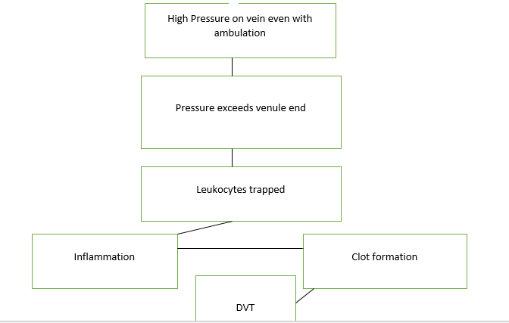
Figure 2: Mind Map of CVI
References
Fukushima, K., Takahira, N., Uchiyama, K., Moriya, M., Minato, T., & Takaso, M. (2016). The incidence of deep vein thrombosis (DVT) during hip arthroscopic surgery. Archives of Orthopaedic and Trauma Surgery, 136(10), 1431-1435. doi:10.1007/s00402-016-2508-7
Michiels, J. J., Maasland, H., Moossdorff, W., Lao, M., Gadiseur, A., & Schroyens, W. (2016). Safe Exclusion of Deep Vein Thrombosis by a Rapid Sensitive ELISA D-dimer and Compression Ultrasonography in 1330 Outpatients with Suspected DVT. Angiology, 67(8), 781-787. doi:10.1177/0003319715616007
Boulton, A., Fenton, M., Loka, T., Sharif, Z., & Greenfield, S. (2015). Public Knowledge of Deep Vein Thrombosis (DVT): A Street Survey in the Suburbs of Birmingham, UK. Quality In Primary Care, 23(1), 31-39.
Büyükyılmaz, F., Şendir, M., Autar, R., & Yazgan, İ. (2015). Risk level analysis for deep vein thrombosis (DVT): A study of Turkish patients undergoing major orthopedic surgery. Journal of Vascular Nursing: Official Publication Of The Society For Peripheral Vascular Nursing, 33(3), 100-105. doi:10.1016/j.jvn.2015.01.004
Elder, D. M., & Greer, K. E. (2015). Venous disease: How to heal and prevent chronic leg ulcers. Geriatrics, 50(8), 30.

